

Appropriation Act (No. 2) 2000-2001

No. 82, 2000

Appropriation Act (No. 2) 2000-2001

No. 82, 2000

An Act to appropriate money out of the Consolidated Revenue Fund for certain expenditure, and for related purposes

Contents
Part 1—Preliminary 11
1 Short title 11
2 Commencement 12
3 Definitions 12
4 Portfolio Budget Statements 13
5 Notional payments, receipts etc. 13
Part 2—Basic appropriations 14
6 Summary of basic appropriations 14
7 State payment items—basic appropriation 14
8 Administered items—basic appropriation 14
9 Administered capital items—basic appropriation 15
10 Departmental capital items—basic appropriation 15
Part 3—Additions to basic appropriations 16
11 Advance to the Finance Minister—unforeseen expenditure etc. 16
12 Departmental capital items—adjustments and borrowings 16
Part 4—Miscellaneous 17
13 Crediting amounts to Special Accounts 17
14 Conditions etc. applying to State payment items 17
15 Appropriation of the Consolidated Revenue Fund 18
Schedule 1—Payments to or for the States 11
Schedule 2—Services for which money is appropriated 15

Appropriation Act (No. 2) 2000-2001
No. 82, 2000

An Act to appropriate money out of the Consolidated Revenue Fund for certain expenditure, and for related purposes
[Assented to 30 June 2000]

The Parliament of Australia enacts:

Part 1—Preliminary

1 Short title
This Act may be cited as the Appropriation Act (No. 2) 2000-2001.

2 Commencement
This Act commences on the day on which it receives the Royal Assent.

3 Definitions
In this Act, unless the contrary intention appears:
administered capital item means an amount set out in Schedule 2 in relation to an entity opposite the heading “Administered Capital”.
administered item means an amount set out in Schedule 2 opposite an outcome of an entity under the heading “Other Administered Expenses”.
Agency has the same meaning as in the Financial Management and Accountability Act 1997.
Commonwealth authority has the same meaning as in the Commonwealth Authorities and Companies Act 1997.
Commonwealth company has the same meaning as in the Commonwealth Authorities and Companies Act 1997.
current year means the financial year ending on 30 June 2001.
departmental capital item means an amount set out in Schedule 2 in relation to an entity:
(a) opposite the heading “Equity Injections”; or
(b) opposite the heading “Loans”; or
(c) opposite the heading “Carryover from previous years”.
entity means any of the following:
(a) an Agency;
(b) a Commonwealth authority;
(c) a Commonwealth company.
expenditure means payments for expenses, acquiring assets, making loans or paying liabilities.
Finance Minister means the Minister administering this Act.
item means any of the following:
(a) a State payment item;
(b) an administered item;
(c) an administered capital item;
(d) a departmental capital item.
Portfolio Budget Statements means the Portfolio Budget Statements that were tabled in the House of Representatives in relation to the Bill for this Act.
section 31 agreement means an agreement under section 31 of the Financial Management and Accountability Act 1997.
Special Account has the same meaning as in the Financial Management and Accountability Act 1997.
State includes the Australian Capital Territory and the Northern Territory.
State payment item means an amount set out in Schedule 2 opposite an outcome of an entity under the heading “Specific Payments to States and Territories”.

4 Portfolio Budget Statements
(1) The Portfolio Budget Statements are hereby declared to be a relevant document for the purposes of section 15AB of the Acts Interpretation Act 1901.
Note: See paragraph 15AB(2)(g) of the Acts Interpretation Act 1901.
(2) If the Portfolio Budget Statements indicate that activities of a particular kind were intended to be treated as activities in respect of a particular outcome, then expenditure for the purpose of carrying out those activities is taken to be expenditure for the purpose of contributing to achieving the outcome.

5 Notional payments, receipts etc.
For the purposes of this Act, notional transactions between Agencies are to be treated as if they were real transactions.
Note: This section applies, for example, to a “payment” between Agencies that are both part of the Commonwealth. One of the effects of this section is that the payment will be debited from an appropriation for the paying Agency, even though no payment is actually made from the Consolidated Revenue Fund.

Part 2—Basic appropriations

6 Summary of basic appropriations
The total of the items specified in Schedule 2 is $5,128,526,000.
Note 1: Items in Schedule 2 can be increased under Part 3 of this Act and under section 12 of the Appropriation Act (No. 1) 2000-2001.
Note 2: See also section 30A of the Financial Management and Accountability Act 1997, which provides for adjustment of appropriations to take account of GST.

7 State payment items—basic appropriation
(1) For a State payment item for an outcome of an entity, the Finance Minister may issue out of the Consolidated Revenue Fund amounts that do not exceed, in total, the lesser of:
(a) the amount specified in the item; and
(b) the amount determined by the Finance Minister in relation to the item, having regard to the expenses incurred by the entity in the current year in relation to the item.
(2) An amount issued out of the Consolidated Revenue Fund for a State payment item for an outcome of an entity may only be applied for the purpose of making payments to or for the States for the purpose of contributing to achieving that outcome.

8 Administered items—basic appropriation
(1) For an administered item for an outcome of an entity, the Finance Minister may issue out of the Consolidated Revenue Fund amounts that do not exceed, in total, the lesser of:
(a) the amount specified in the item; and
(b) the amount determined by the Finance Minister in relation to the item, having regard to the expenses incurred by the entity in the current year in relation to the item.
(2) An amount issued out of the Consolidated Revenue Fund for an administered item for an outcome of an entity may only be applied for expenditure for the purpose of carrying out activities for the purpose of contributing to achieving that outcome.
Note: The acquisition of new administered assets will usually be funded from an administered capital item.

9 Administered capital items—basic appropriation
(1) For an administered capital item for an entity, the Finance Minister may issue out of the Consolidated Revenue Fund amounts that do not exceed, in total, the amount specified in the item.
(2) An amount issued out of the Consolidated Revenue Fund for an administered capital item for an entity may only be applied for expenditure for the purpose of carrying out activities for the purpose of contributing to achieving any outcome that is specified in relation to the entity:
(a) in Schedule 2 to this Act; or
(b) in the Schedule to the Appropriation Act (No. 1) 2000-2001.

10 Departmental capital items—basic appropriation
(1) For a departmental capital item for an entity, the Finance Minister may issue out of the Consolidated Revenue Fund amounts that do not exceed, in total, the amount specified in the item.
Note: Generally, the Finance Minister is permitted, but not obliged, to issue the amounts out of the Consolidated Revenue Fund. However, subsection (3) imposes an obligation on the Finance Minister to issue the amounts in certain circumstances.
(2) An amount issued out of the Consolidated Revenue Fund for a departmental capital item may only be applied for the departmental expenditure of the entity.
(3) If:
(a) an Act provides that an entity must be paid amounts that are appropriated by the Parliament for the purposes of the entity; and
(b) Schedule 2 contains a departmental capital item for that entity;
then the Finance Minister, under subsection (1), must issue out of the Consolidated Revenue Fund the full amount specified in the item.

Part 3—Additions to basic appropriations

11 Advance to the Finance Minister—unforeseen expenditure etc.
(1) This section applies if the Finance Minister is satisfied that:
(a) there is an urgent need for expenditure that is not provided for, or is insufficiently provided for, in Schedule 2; and
(b) the additional expenditure is not provided for, or is insufficiently provided for, in that Schedule:
(i) because of an erroneous omission or understatement; or
(ii) because the additional expenditure was unforeseen until after the last day on which it was practicable to provide for it in the Bill for this Act before that Bill was introduced into the House of Representatives.
(2) This Act has effect as if that Schedule were amended, in accordance with a determination of the Finance Minister, to make provision for so much (if any) of the additional expenditure as the Finance Minister determines.
(3) The total of the amounts determined under this section cannot be more than $215 million.
(4) The Finance Minister must give the Parliament details of amounts determined under this section.

12 Departmental capital items—adjustments and borrowings
(1) The Finance Minister may determine that the amount specified in a departmental capital item is to be increased by an amount specified in the determination.
(2) The total of the amounts determined by the Finance Minister under subsection (1) cannot be more than $20 million.
(3) The Finance Minister must give the Parliament details of increases made under this section.

Part 4—Miscellaneous

13 Crediting amounts to Special Accounts
If any of the purposes of a Special Account is a purpose that is covered by an item (whether or not the item expressly refers to the Special Account), then amounts may be debited against the appropriation for that item and credited to that Special Account.

14 Conditions etc. applying to State payment items
(1) This section applies to any payment made out of money appropriated by a State payment item for an outcome identified in columns 2 and 3 of the table in Schedule 1.
(2) The payment:
(a) must be made on the applicable terms and conditions (if any) for that outcome; and
(b) must be made in the amounts, and at the times, that are determined in writing by the Minister specified in column 5 of the table.
(3) This section does not, by implication, limit the power of the Commonwealth to:
(a) apply terms and conditions to non-State payments; or
(b) determine the amounts and times of non-State payments.
(4) In this section:
applicable terms and conditions, in relation to an outcome identified in the table in Schedule 1, means terms and conditions from time to time determined in writing by the Minister specified in column 4 of the table, either before or after the commencement of this Act, as being the terms and conditions that apply to payments that are made to or for a State in relation to that outcome out of money appropriated by an annual Appropriation Act.
non-State payment means a payment made out of money that is appropriated by the Parliament (either under this Act or another Act), other than a payment out of money appropriated by a State payment item.

15 Appropriation of the Consolidated Revenue Fund
The Consolidated Revenue Fund is appropriated as necessary for the purposes of this Act.

Schedule 1 – Payments to or for the States
Note: See Section 14
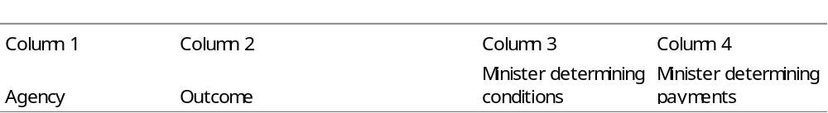
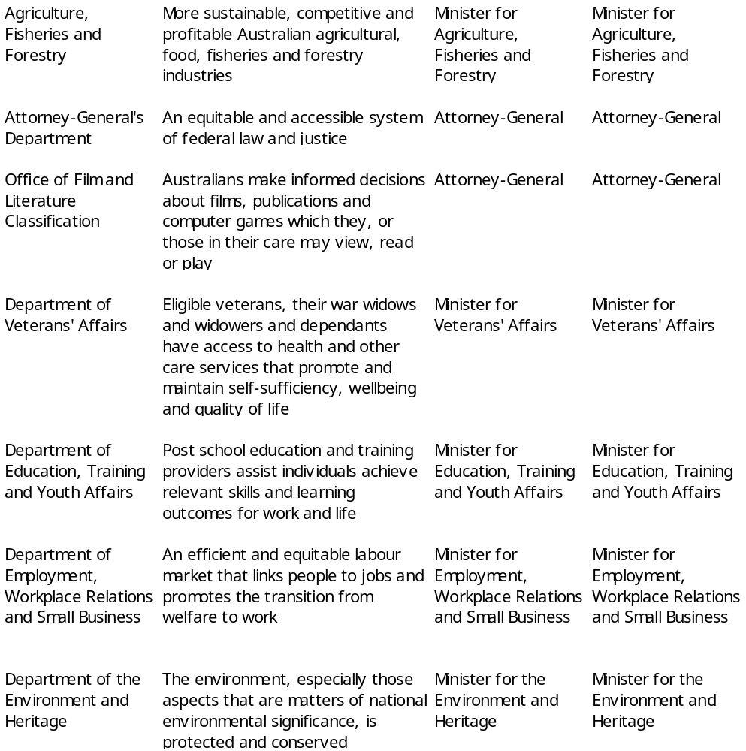
Continued
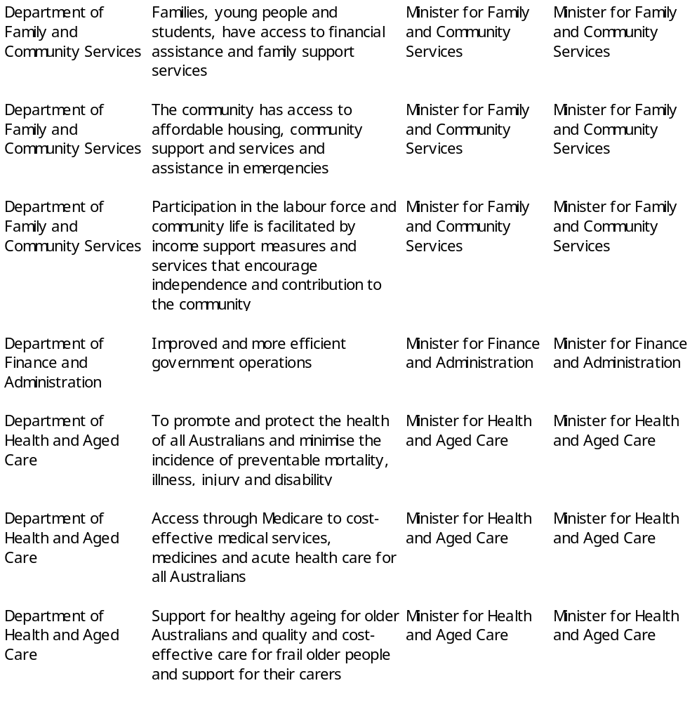
Continued
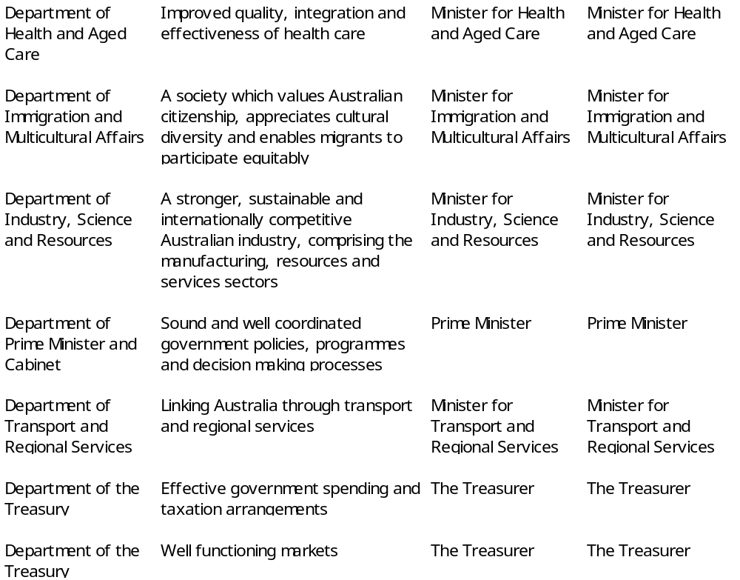

Schedule 2 – Services for which money is appropriated
Note: See Sections 6 and 15
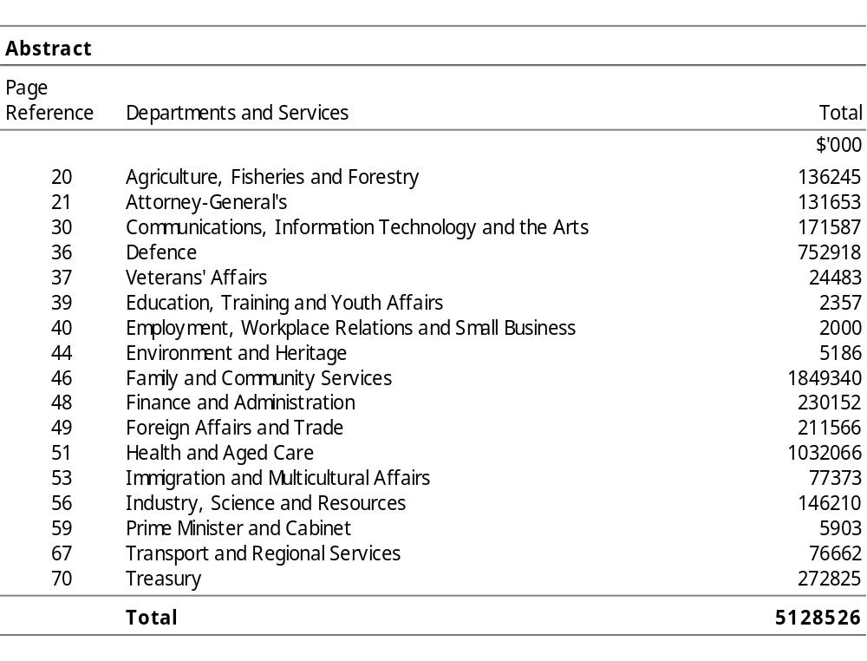

DEPARTMENTS AND SERVICES

Summary
Appropriation (light figures) – 2000-2001
Estimate (italic figures) – 1999-2000
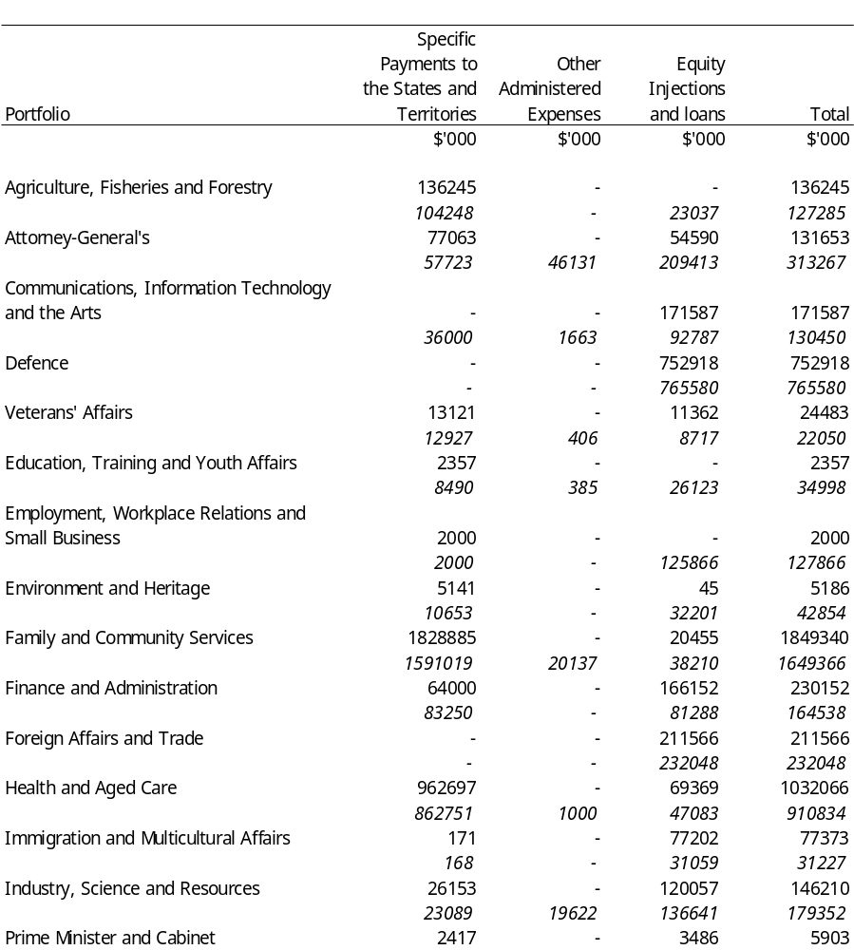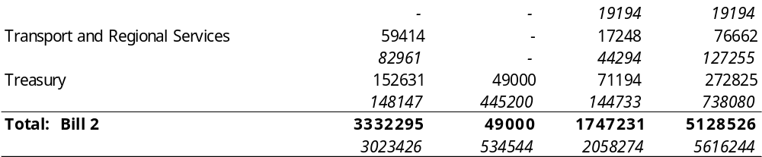
Title
Appropriation (light figures) – 2000-2001
Estimate (italic figures) – 1999-2000
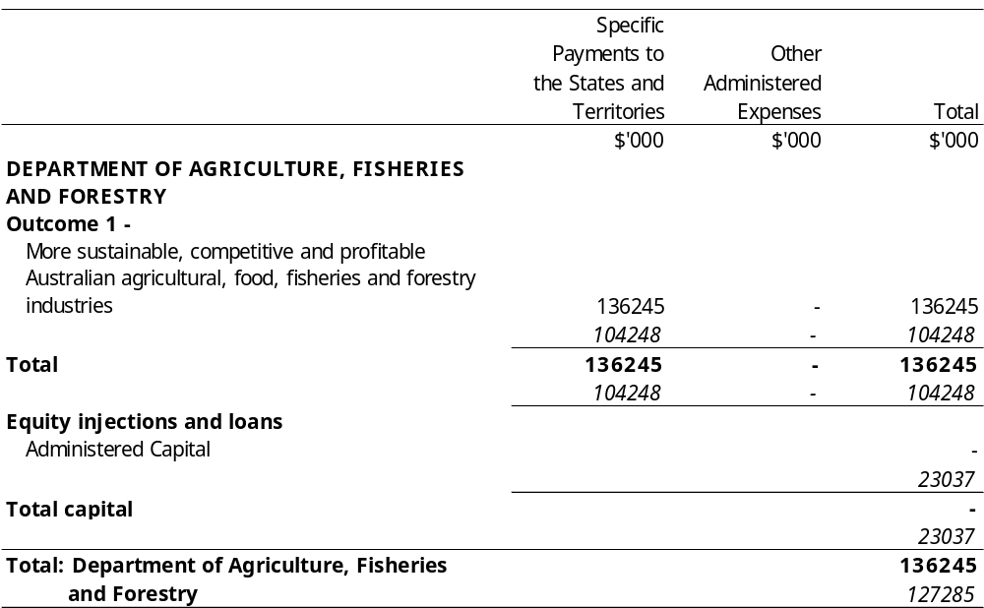
Title
Appropriation (light figures) – 2000-2001
Estimate (italic figures) – 1999-2000
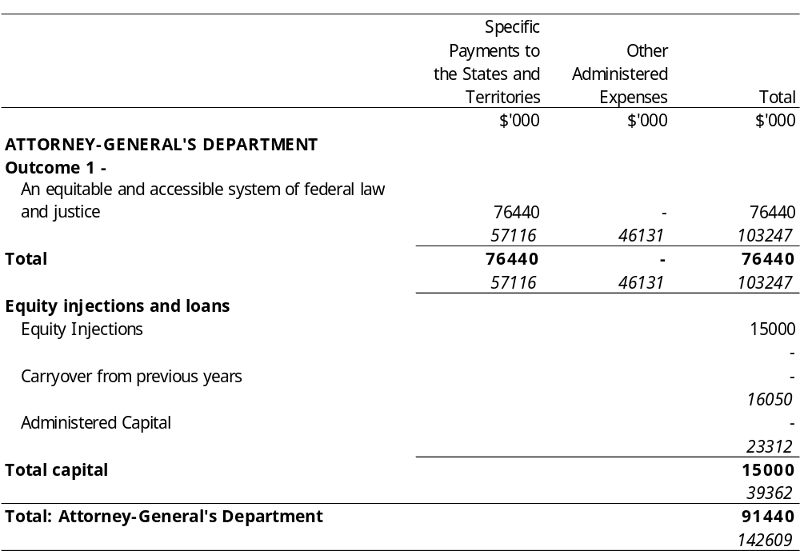
Title
Appropriation (light figures) – 2000-2001
Estimate (italic figures) – 1999-2000
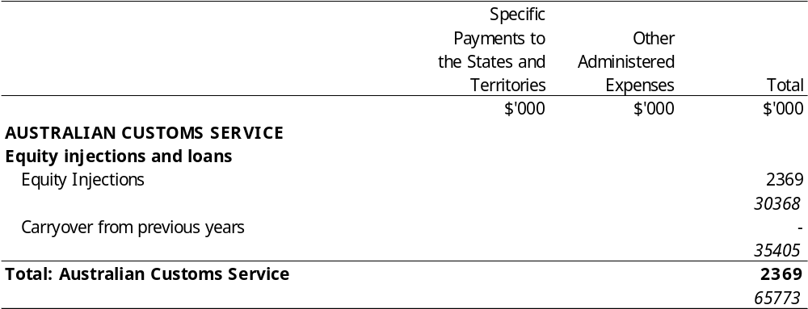
Title
Appropriation (light figures) – 2000-2001
Estimate (italic figures) – 1999-2000
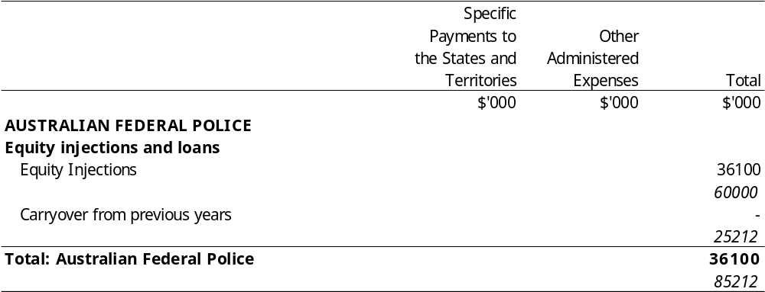
Title
Appropriation (light figures) – 2000-2001
Estimate (italic figures) – 1999-2000
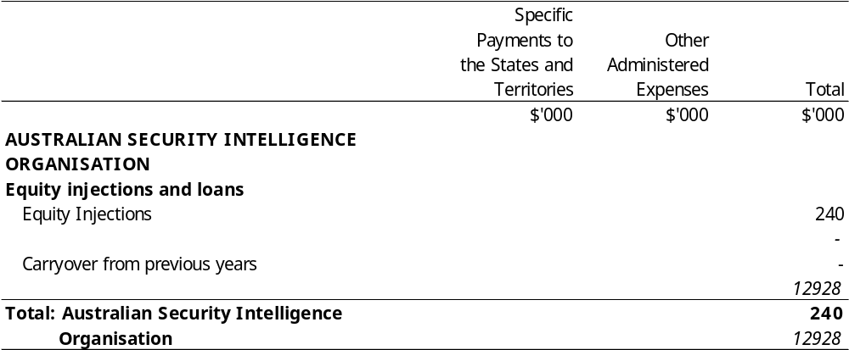
Title
Appropriation (light figures) – 2000-2001
Estimate (italic figures) – 1999-2000
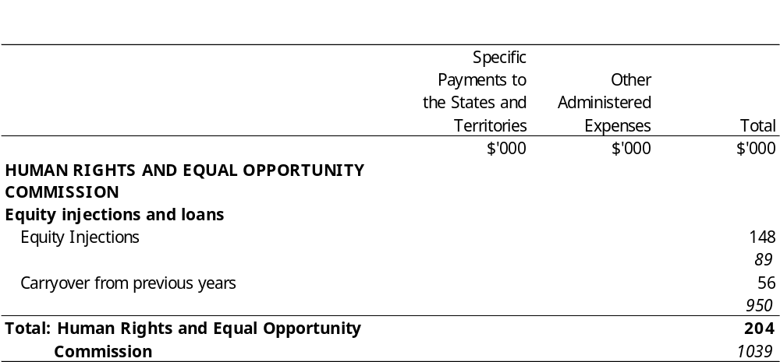
Title
Appropriation (light figures) – 2000-2001
Estimate (italic figures) – 1999-2000
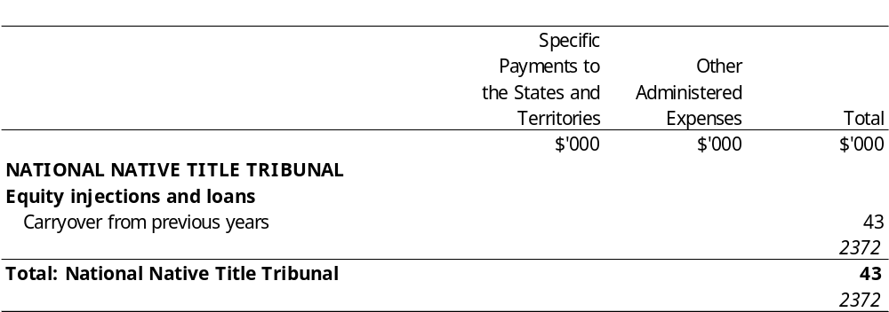
Title
Appropriation (light figures) – 2000-2001
Estimate (italic figures) – 1999-2000
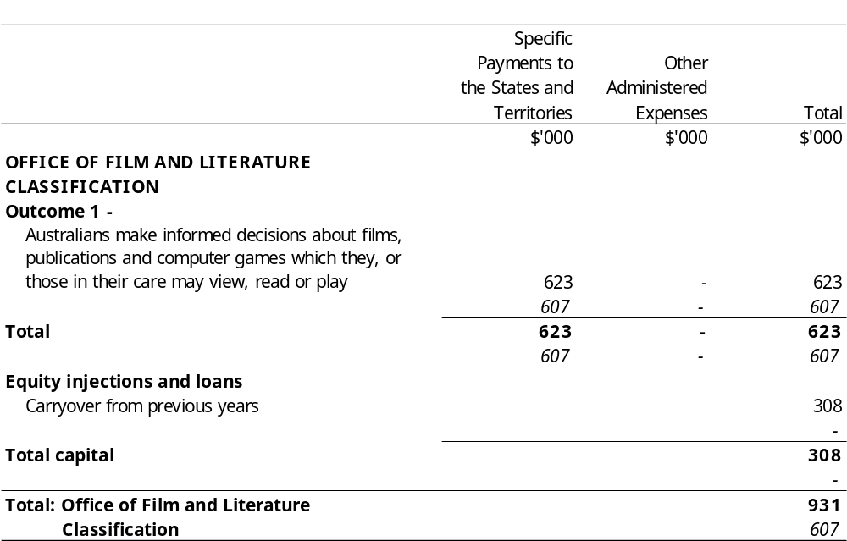
Title
Appropriation (light figures) – 2000-2001
Estimate (italic figures) – 1999-2000
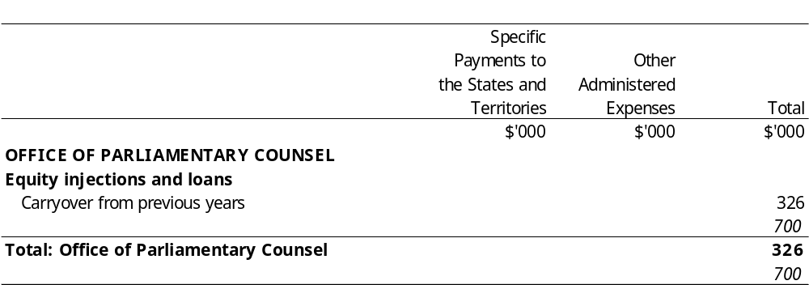
Title
Appropriation (light figures) – 2000-2001
Estimate (italic figures) – 1999-2000
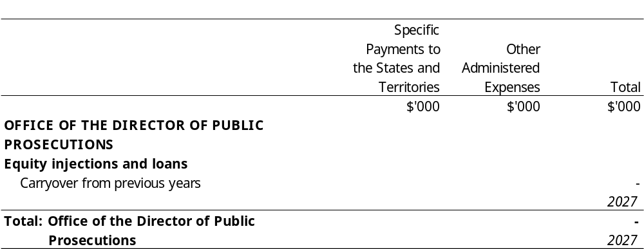
Title
Appropriation (light figures) – 2000-2001
Estimate (italic figures) – 1999-2000
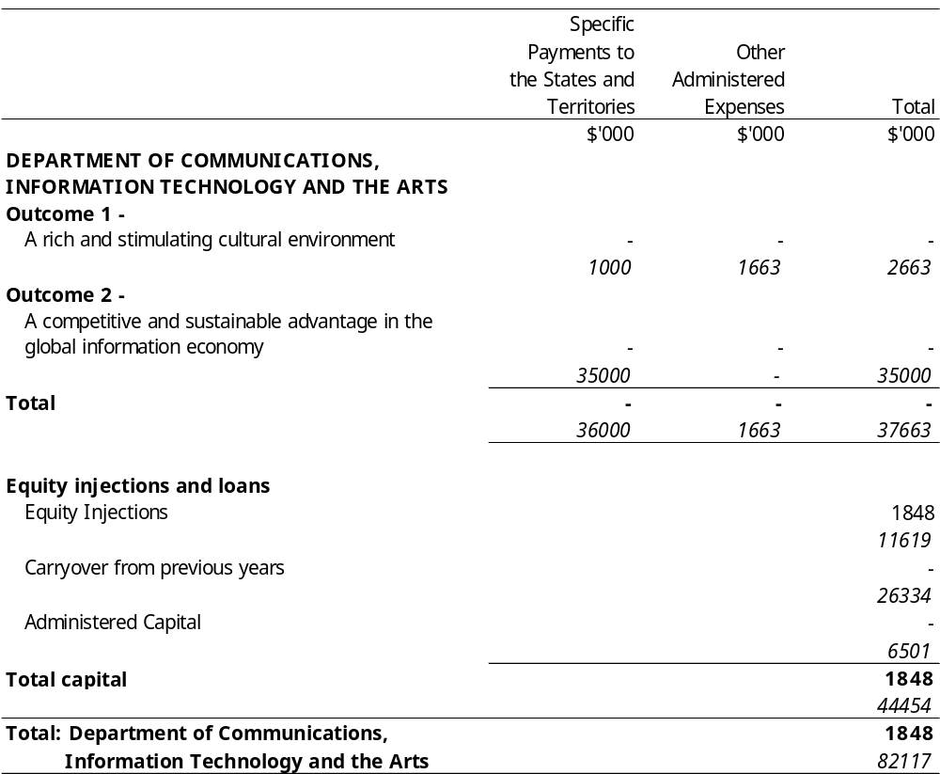
Title
Appropriation (light figures) – 2000-2001
Estimate (italic figures) – 1999-2000
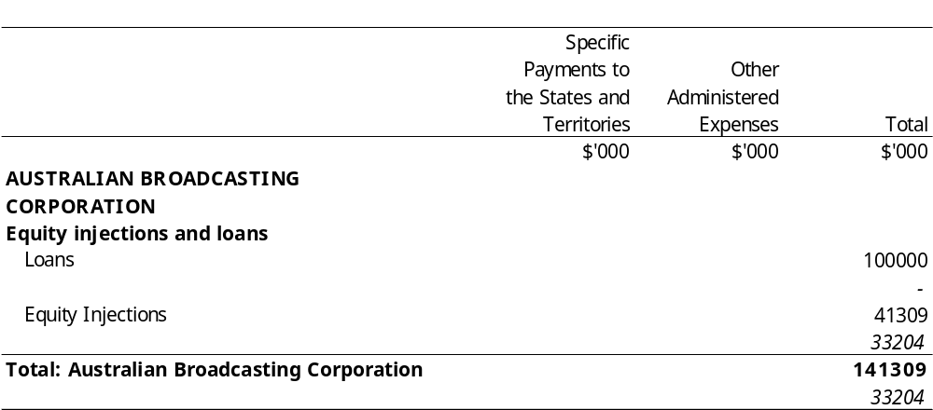
Title
Appropriation (light figures) – 2000-2001
Estimate (italic figures) – 1999-2000
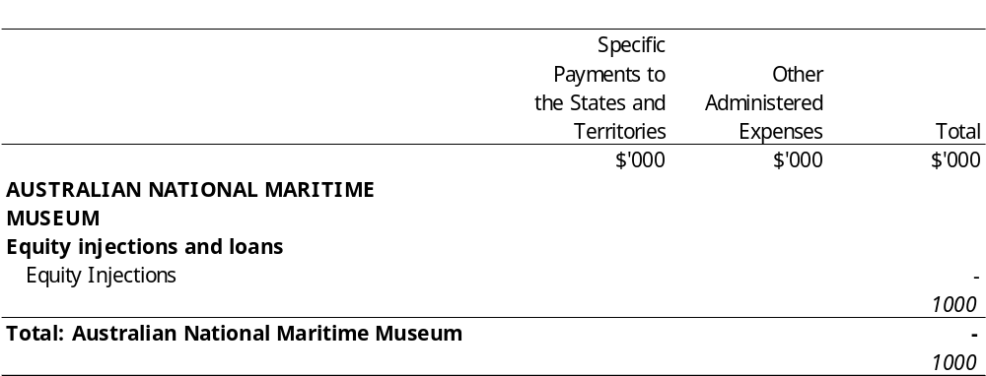
Title
Appropriation (light figures) – 2000-2001
Estimate (italic figures) – 1999-2000
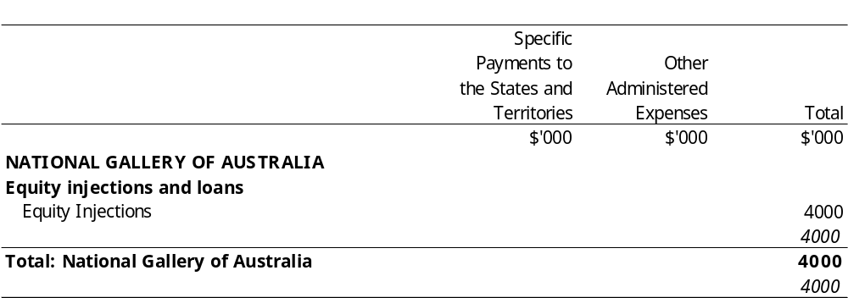
Title
Appropriation (light figures) – 2000-2001
Estimate (italic figures) – 1999-2000
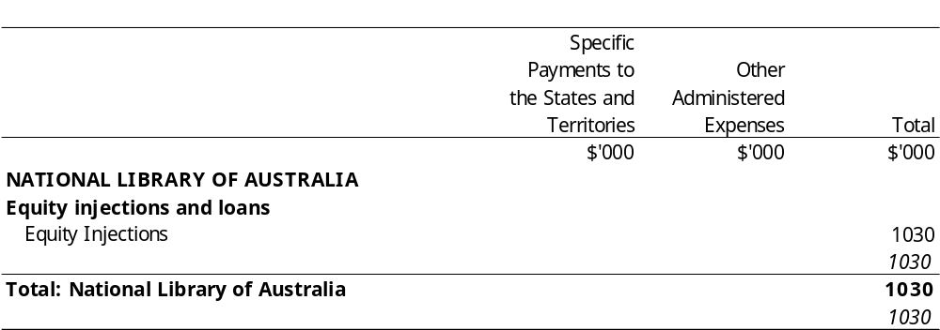
Title
Appropriation (light figures) – 2000-2001
Estimate (italic figures) – 1999-2000
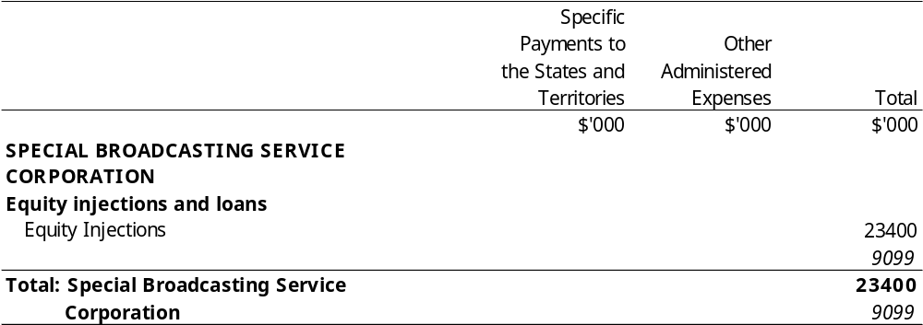
Title
Appropriation (light figures) – 2000-2001
Estimate (italic figures) – 1999-2000
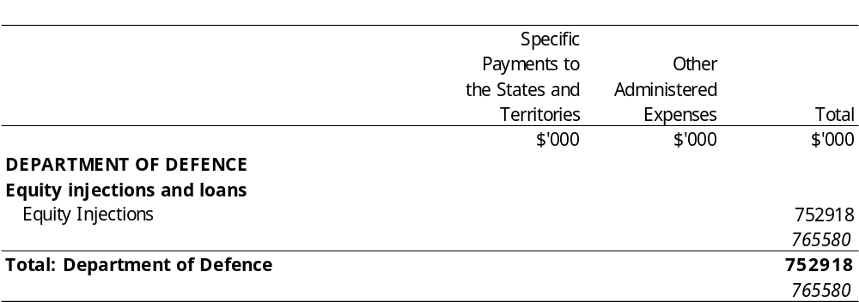
Title
Appropriation (light figures) – 2000-2001
Estimate (italic figures) – 1999-2000
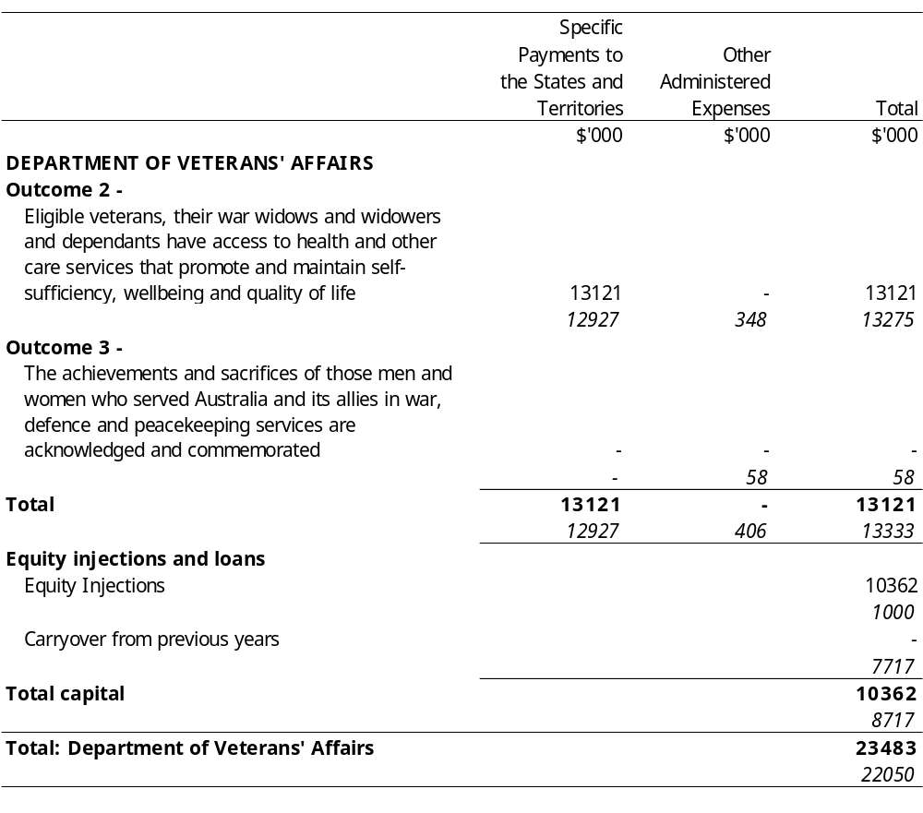
Title
Appropriation (light figures) – 2000-2001
Estimate (italic figures) – 1999-2000
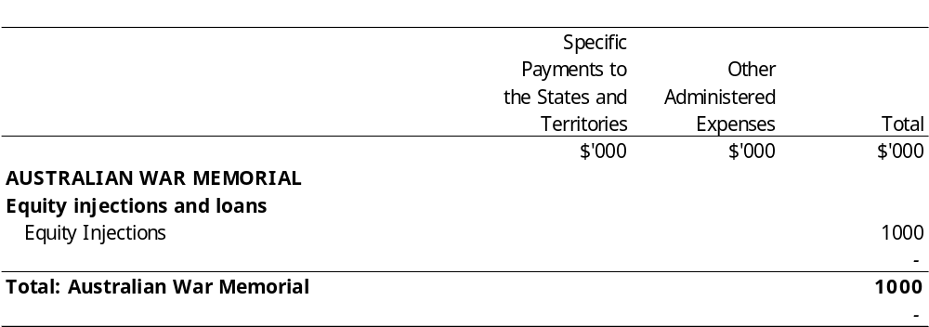
Title
Appropriation (light figures) – 2000-2001
Estimate (italic figures) – 1999-2000
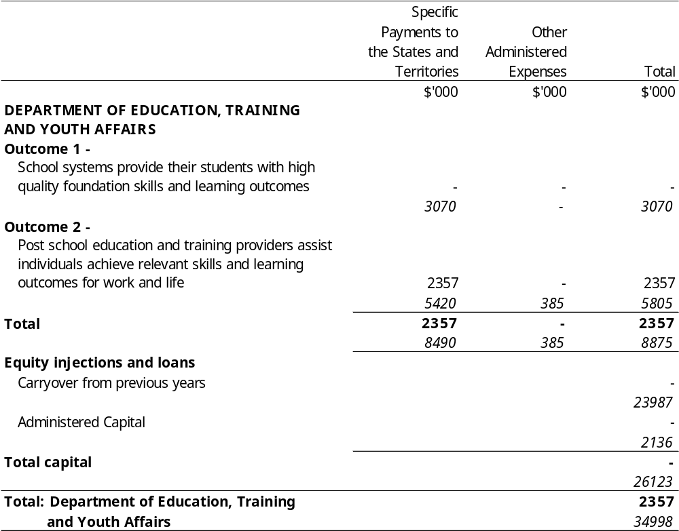
Title
Appropriation (light figures) – 2000-2001
Estimate (italic figures) – 1999-2000
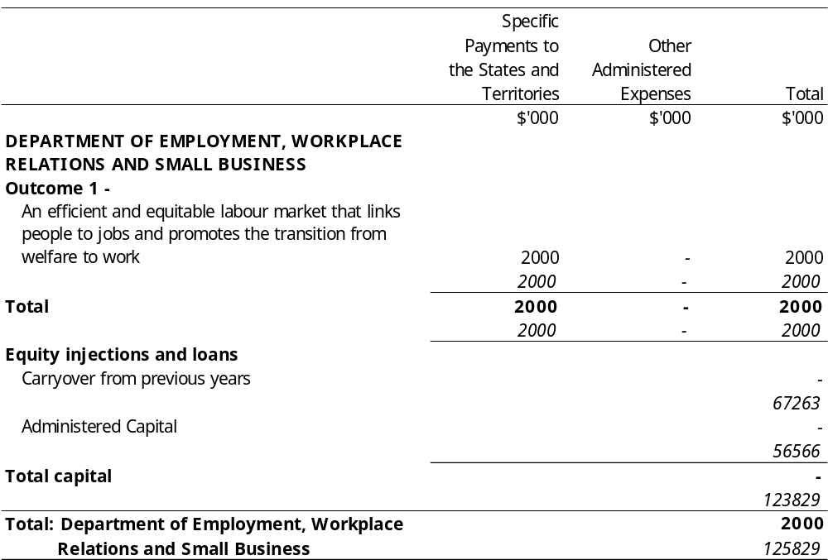
Title
Appropriation (light figures) – 2000-2001
Estimate (italic figures) – 1999-2000
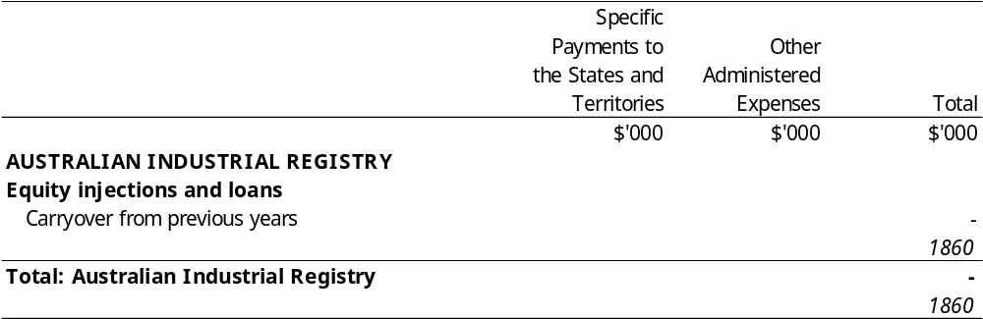
Title
Appropriation (light figures) – 2000-2001
Estimate (italic figures) – 1999-2000
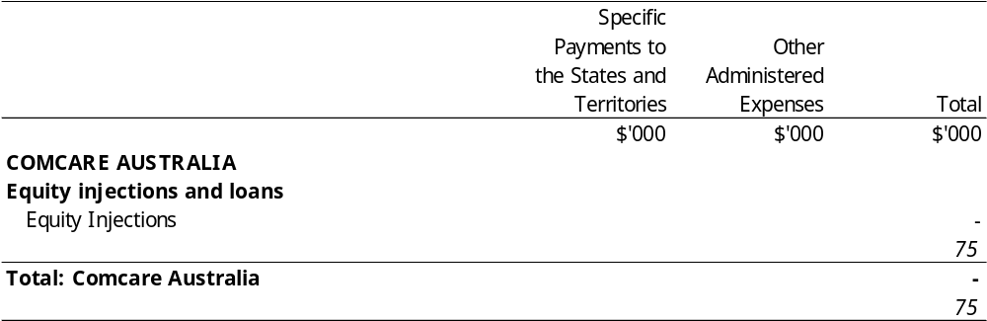
Title
Appropriation (light figures) – 2000-2001
Estimate (italic figures) – 1999-2000
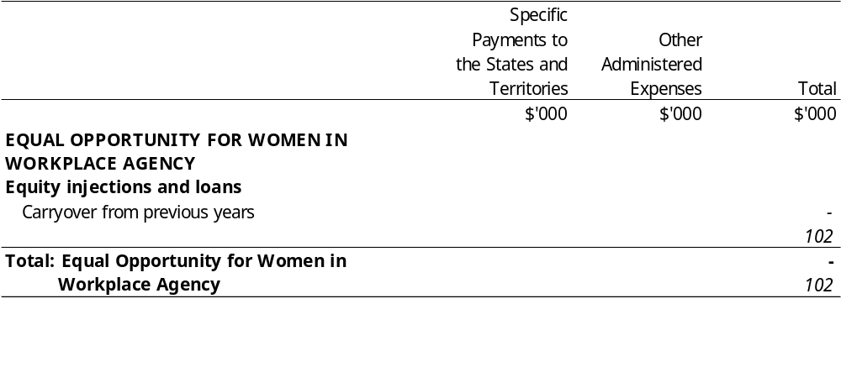
Title
Appropriation (light figures) – 2000-2001
Estimate (italic figures) – 1999-2000
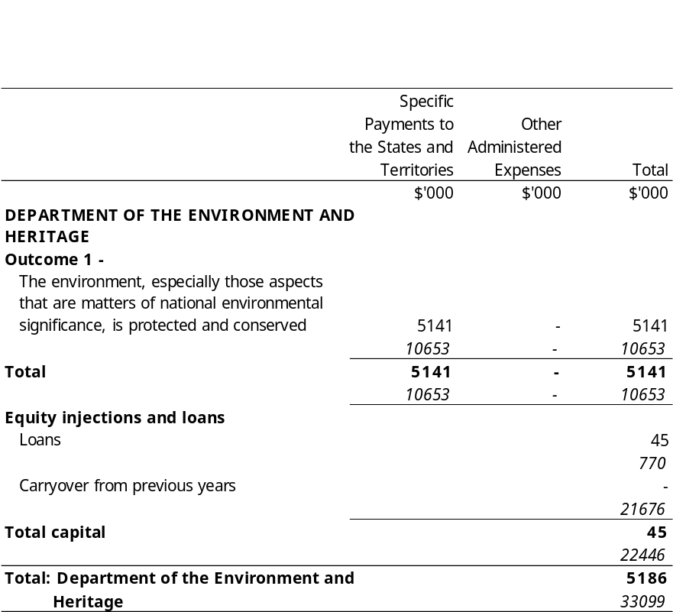
Title
Appropriation (light figures) – 2000-2001
Estimate (italic figures) – 1999-2000
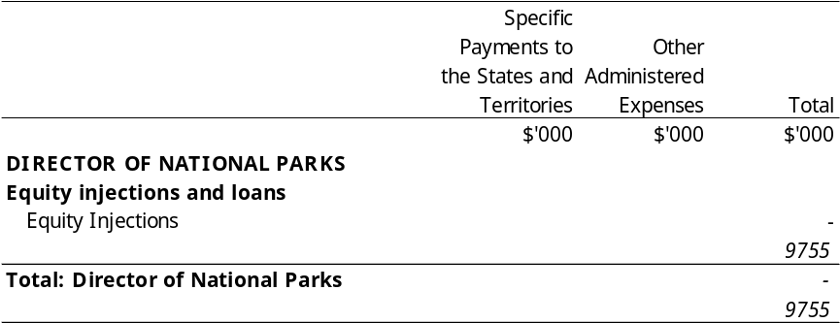
Title
Appropriation (light figures) – 2000-2001
Estimate (italic figures) – 1999-2000
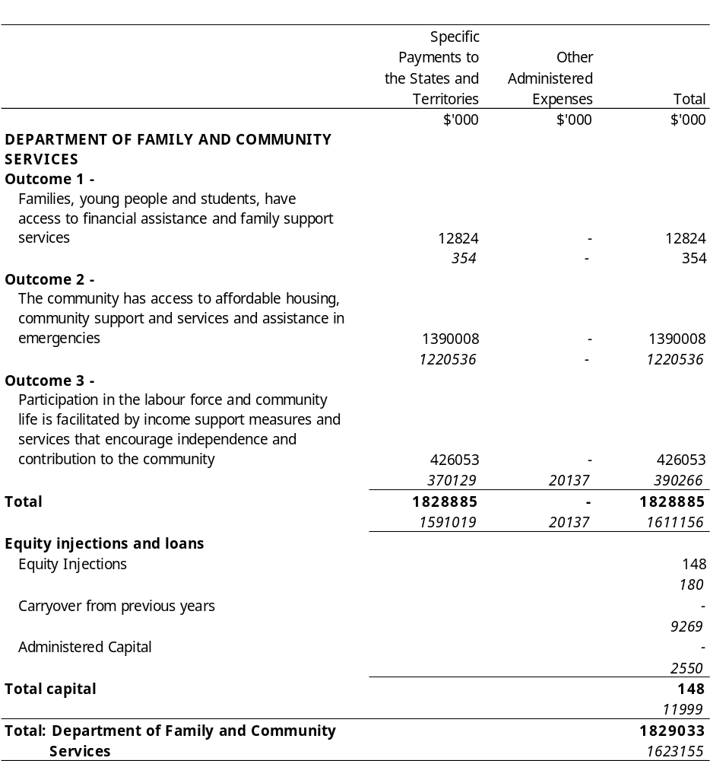
Title
Appropriation (light figures) – 2000-2001
Estimate (italic figures) – 1999-2000
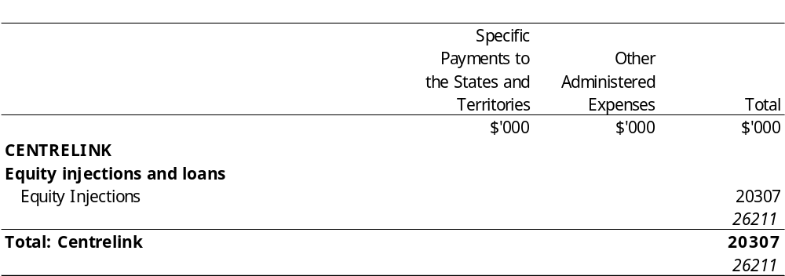
Title
Appropriation (light figures) – 2000-2001
Estimate (italic figures) – 1999-2000
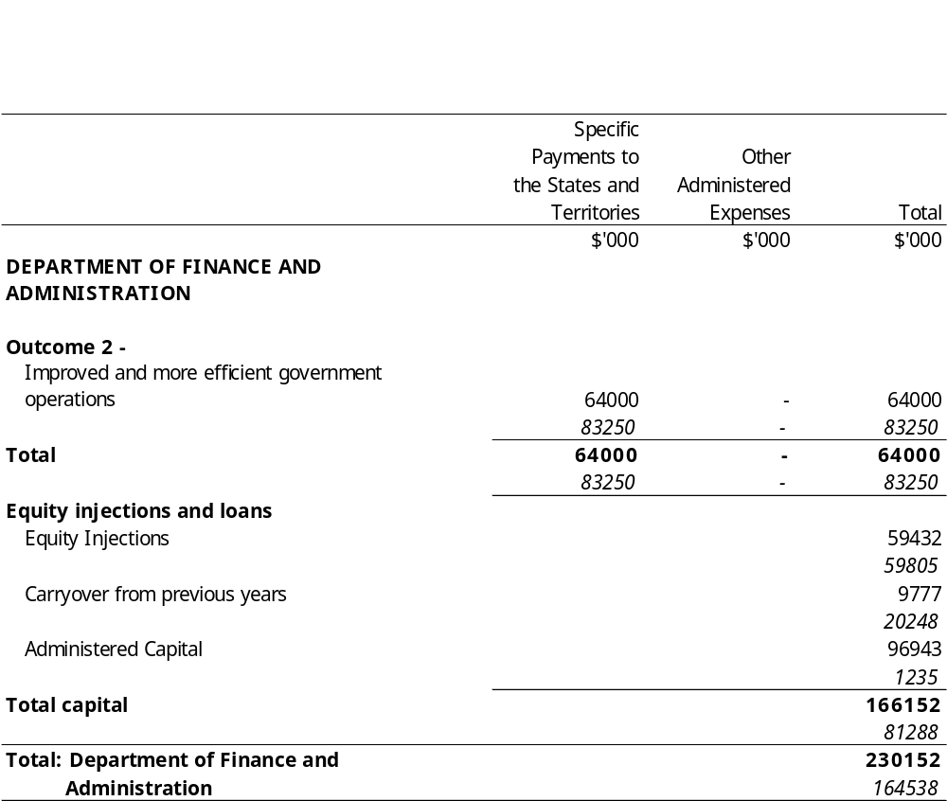
Title
Appropriation (light figures) – 2000-2001
Estimate (italic figures) – 1999-2000
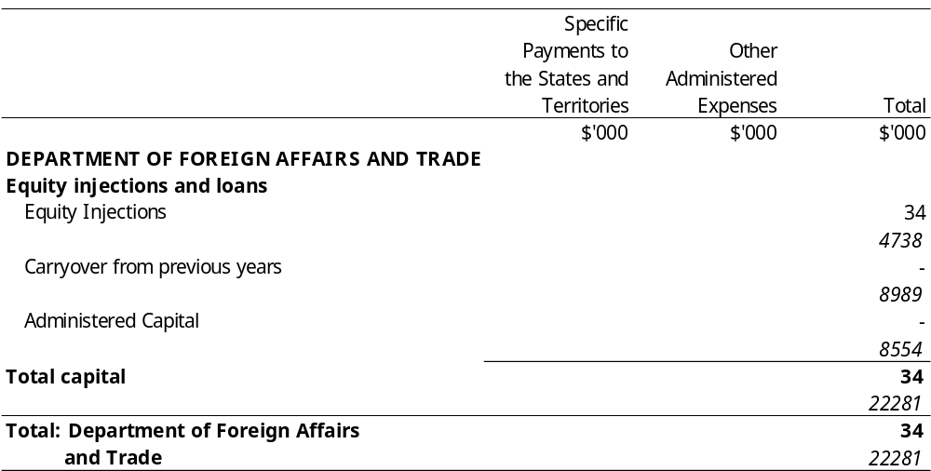
Title
Appropriation (light figures) – 2000-2001
Estimate (italic figures) – 1999-2000
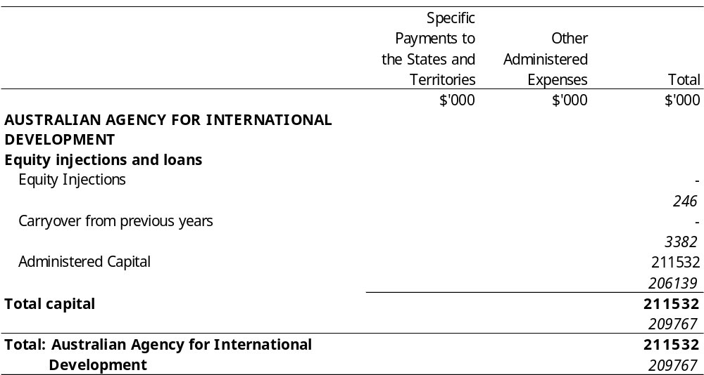
Title
Appropriation (light figures) – 2000-2001
Estimate (italic figures) – 1999-2000
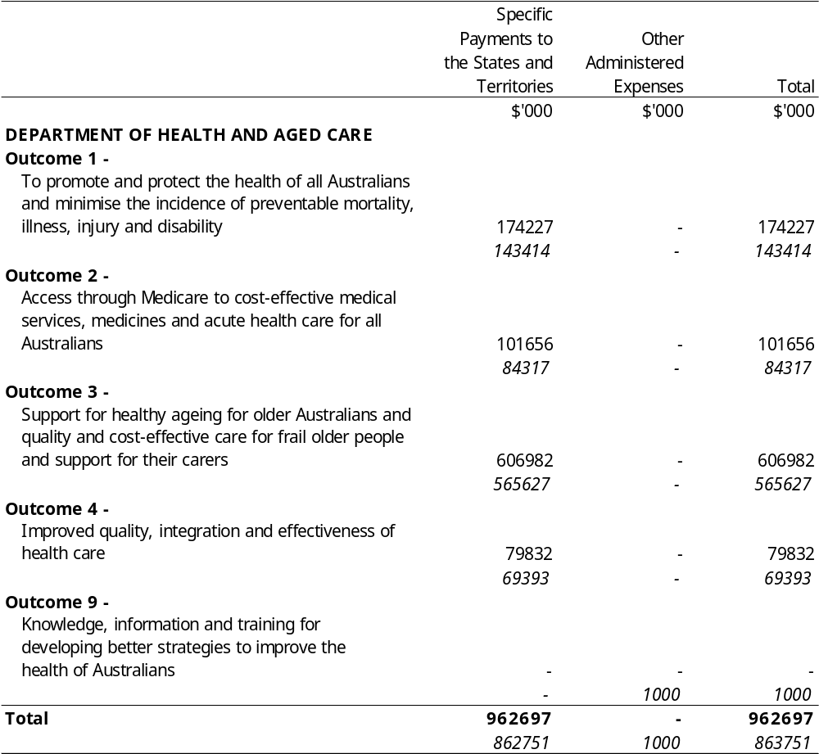
Title
Appropriation (light figures) – 2000-2001
Estimate (italic figures) – 1999-2000
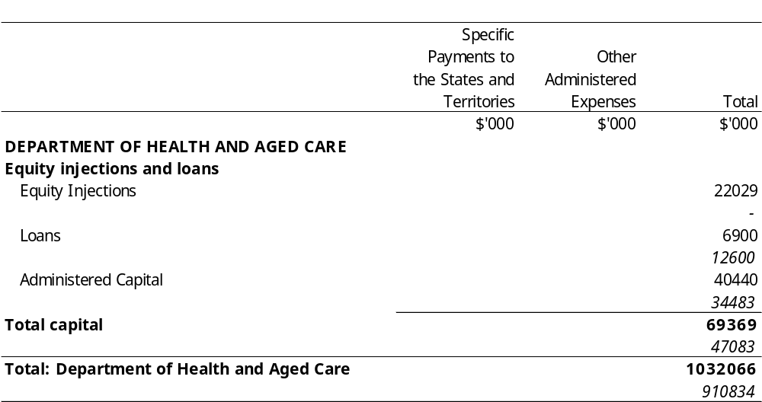
Title
Appropriation (light figures) – 2000-2001
Estimate (italic figures) – 1999-2000
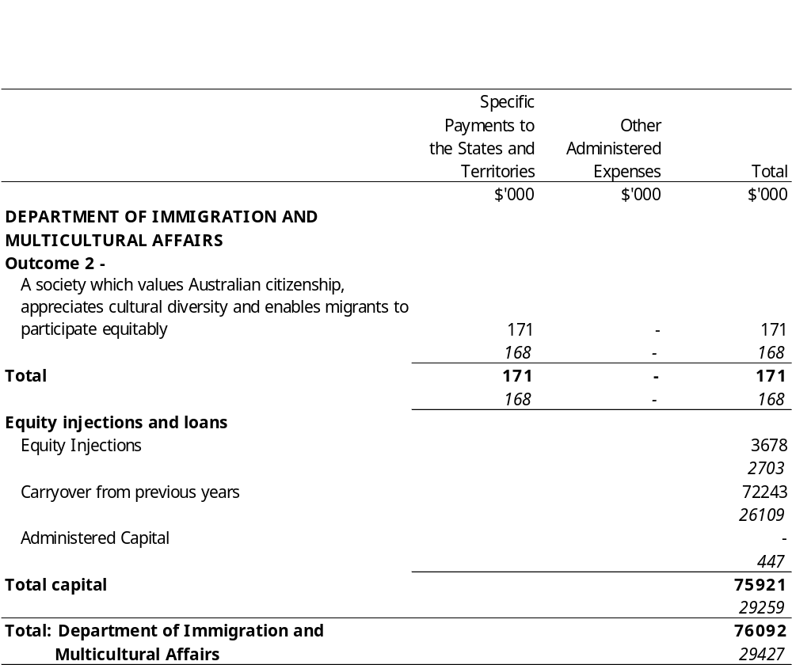
Title
Appropriation (light figures) – 2000-2001
Estimate (italic figures) – 1999-2000
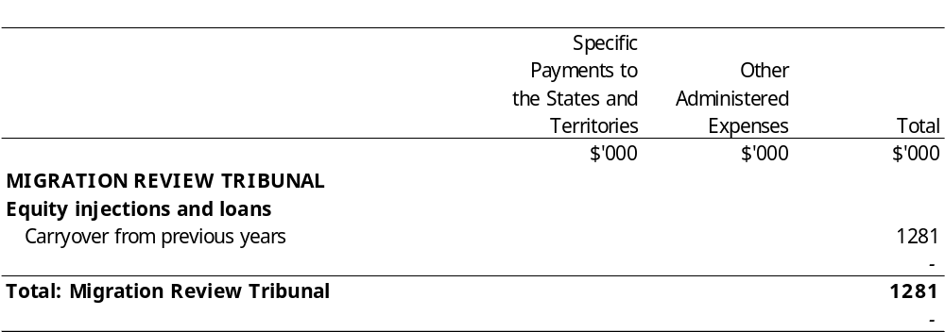
Title
Appropriation (light figures) – 2000-2001
Estimate (italic figures) – 1999-2000
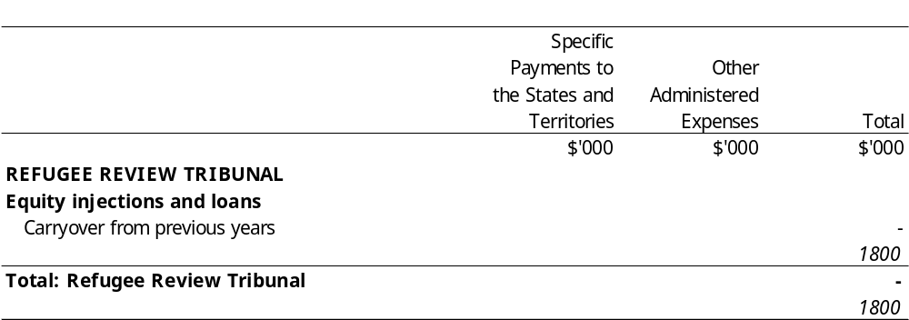
Title
Appropriation (light figures) – 2000-2001
Estimate (italic figures) – 1999-2000
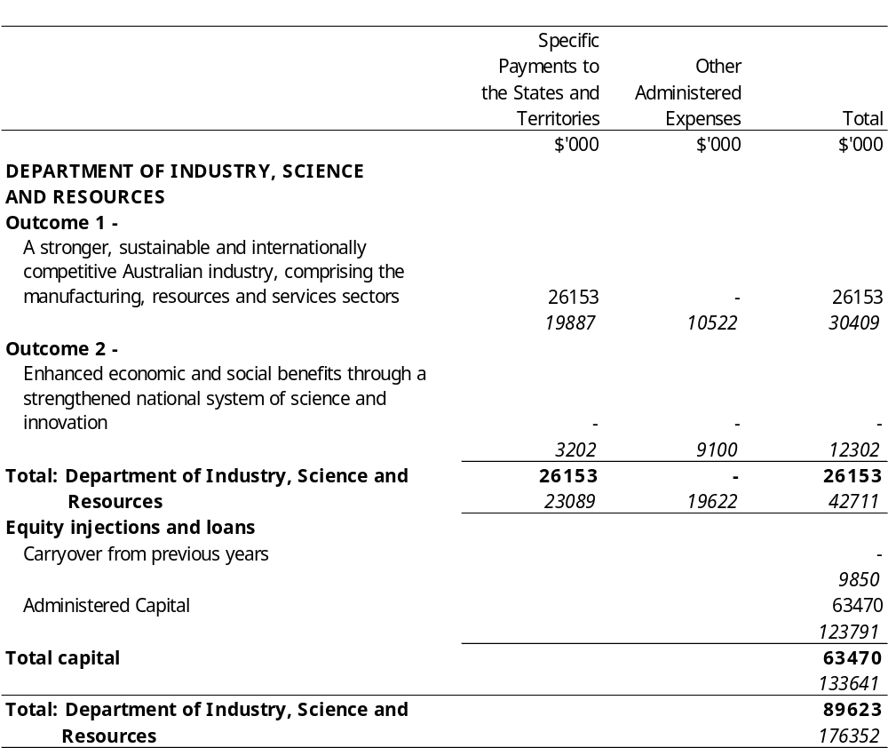
Title
Appropriation (light figures) – 2000-2001
Estimate (italic figures) – 1999-2000
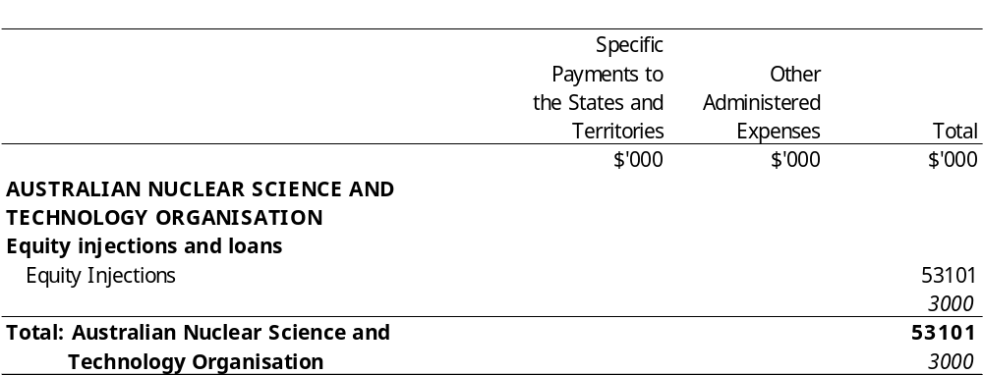
Title
Appropriation (light figures) – 2000-2001
Estimate (italic figures) – 1999-2000
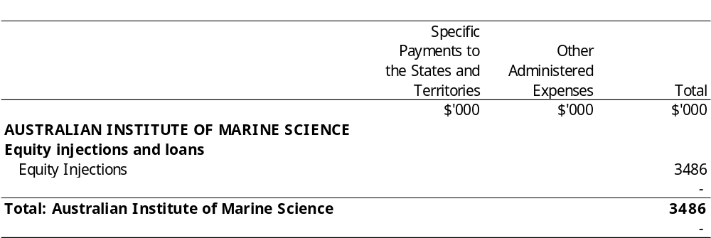
Title
Appropriation (light figures) – 2000-2001
Estimate (italic figures) – 1999-2000
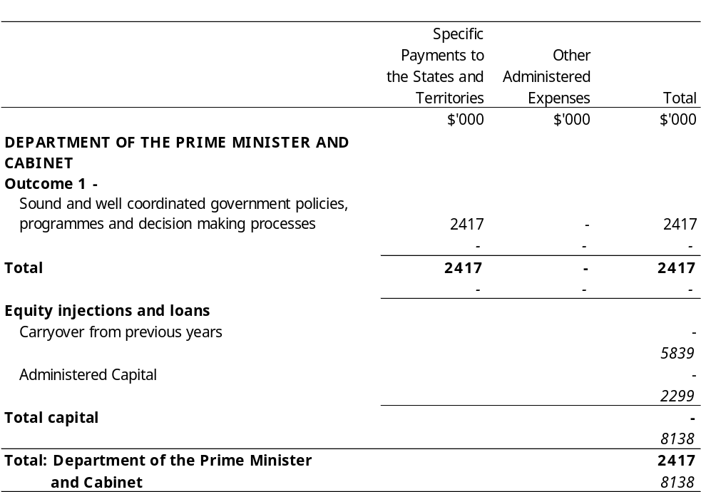
Title
Appropriation (light figures) – 2000-2001
Estimate (italic figures) – 1999-2000
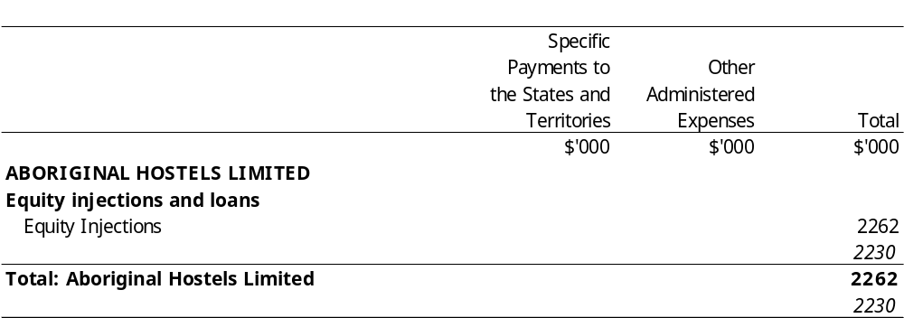
Title
Appropriation (light figures) – 2000-2001
Estimate (italic figures) – 1999-2000
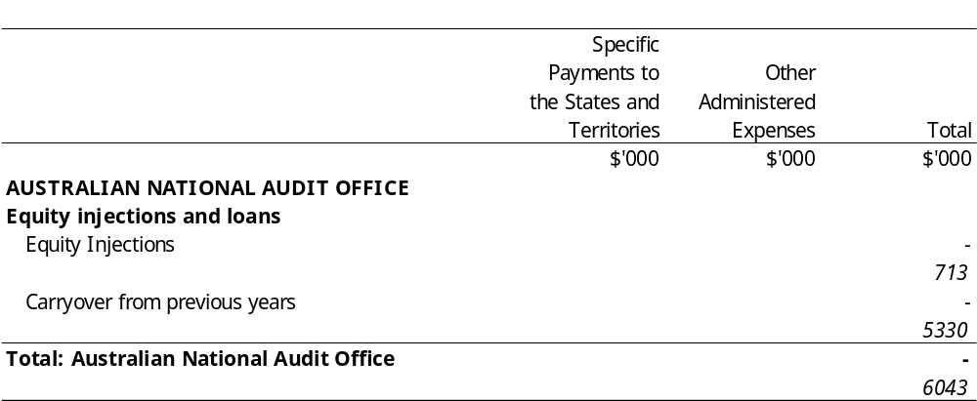
Title
Appropriation (light figures) – 2000-2001
Estimate (italic figures) – 1999-2000
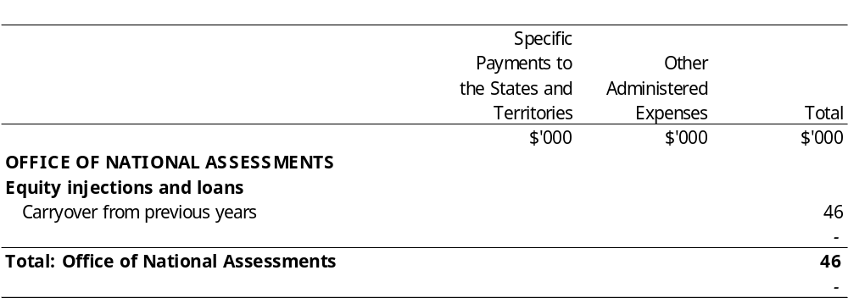
Title
Appropriation (light figures) – 2000-2001
Estimate (italic figures) – 1999-2000
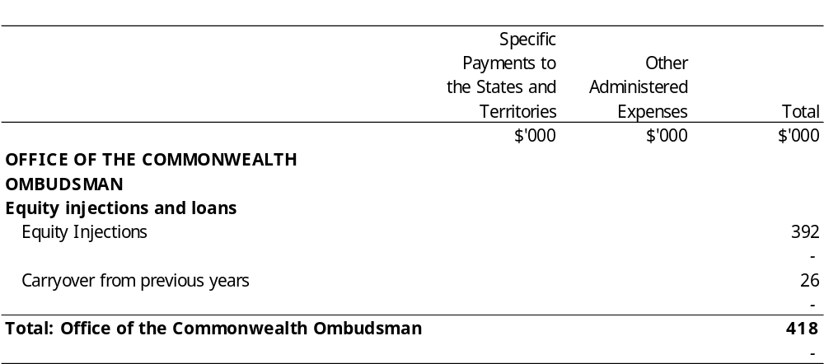
Title
Appropriation (light figures) – 2000-2001
Estimate (italic figures) – 1999-2000
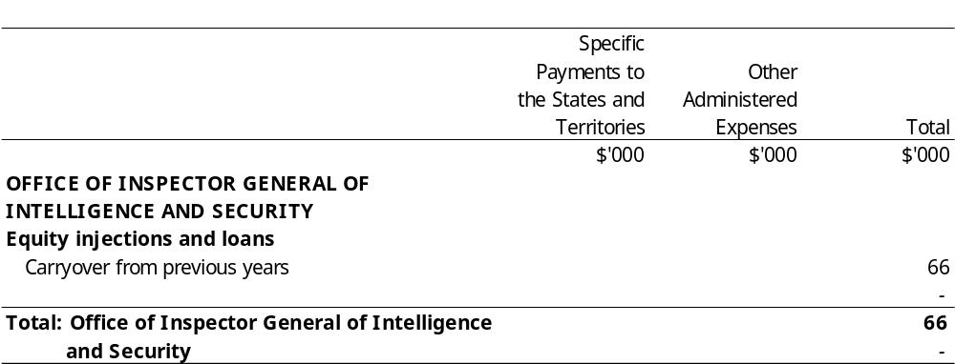
Title
Appropriation (light figures) – 2000-2001
Estimate (italic figures) – 1999-2000
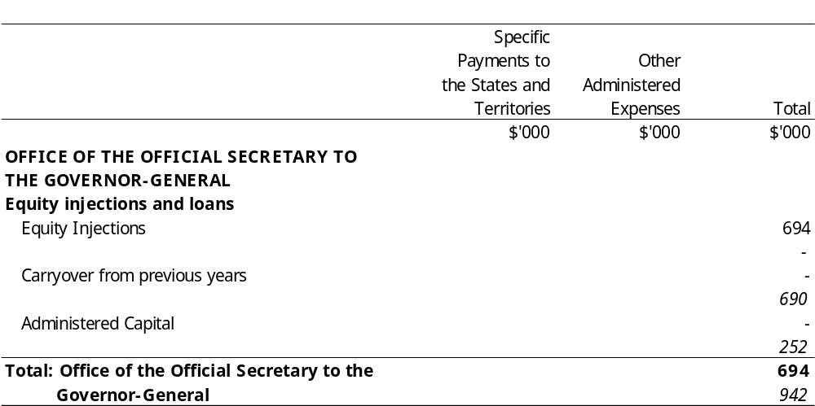
Title
Appropriation (light figures) – 2000-2001
Estimate (italic figures) – 1999-2000
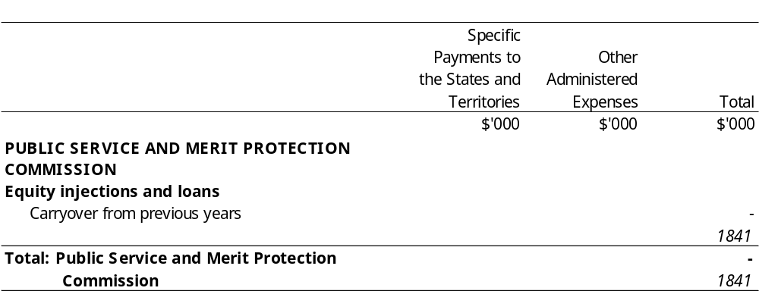
Title
Appropriation (light figures) – 2000-2001
Estimate (italic figures) – 1999-2000
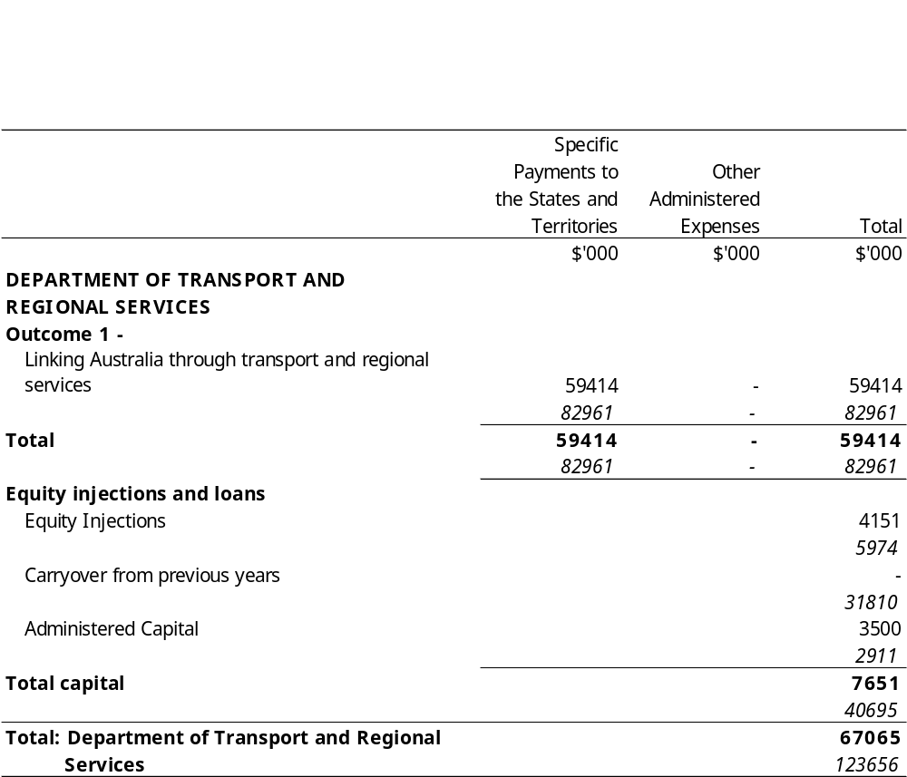
Title
Appropriation (light figures) – 2000-2001
Estimate (italic figures) – 1999-2000
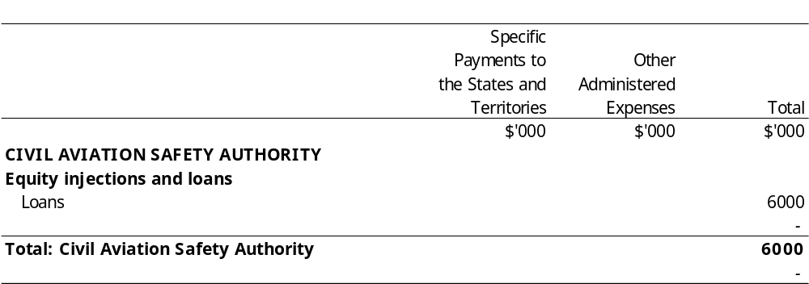
Title
Appropriation (light figures) – 2000-2001
Estimate (italic figures) – 1999-2000
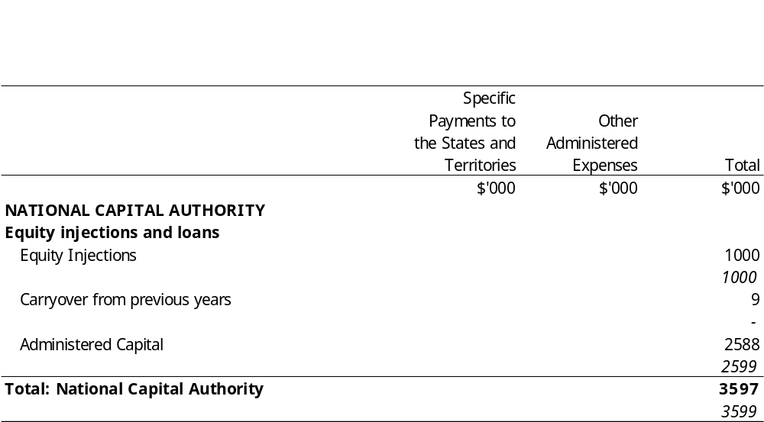
Title
Appropriation (light figures) – 2000-2001
Estimate (italic figures) – 1999-2000
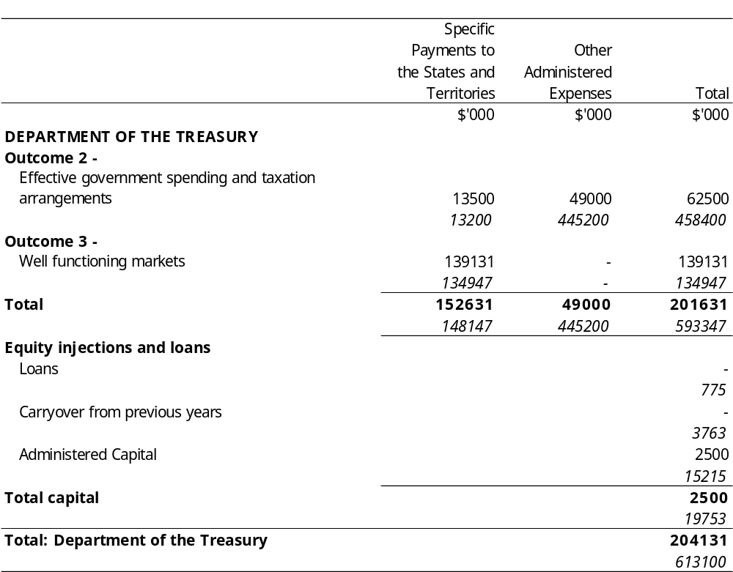
Title
Appropriation (light figures) – 2000-2001
Estimate (italic figures) – 1999-2000
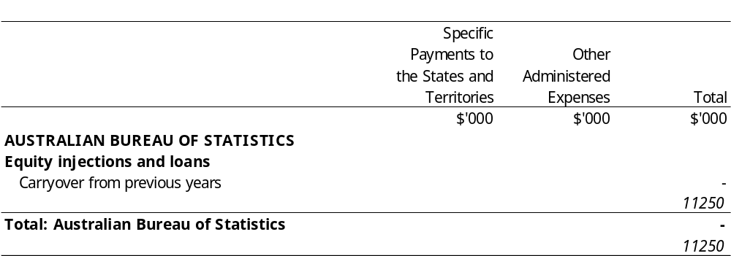
Title
Appropriation (light figures) – 2000-2001
Estimate (italic figures) – 1999-2000
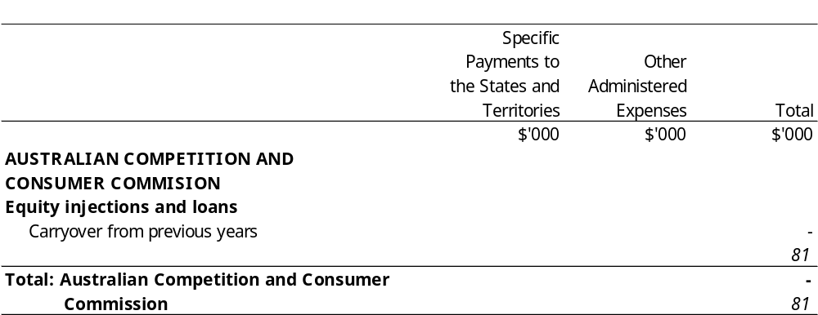
Title
Appropriation (light figures) – 2000-2001
Estimate (italic figures) – 1999-2000
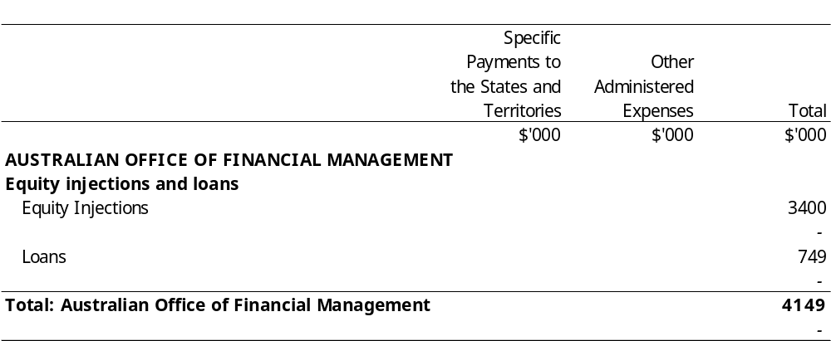
Title
Appropriation (light figures) – 2000-2001
Estimate (italic figures) – 1999-2000
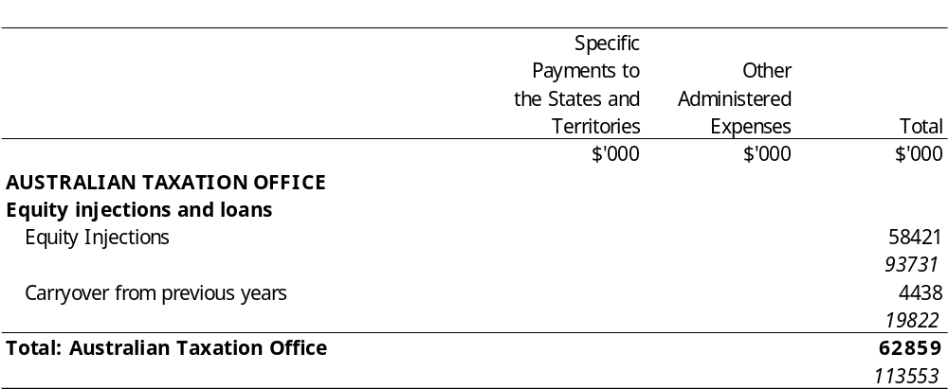
Title
Appropriation (light figures) – 2000-2001
Estimate (italic figures) – 1999-2000
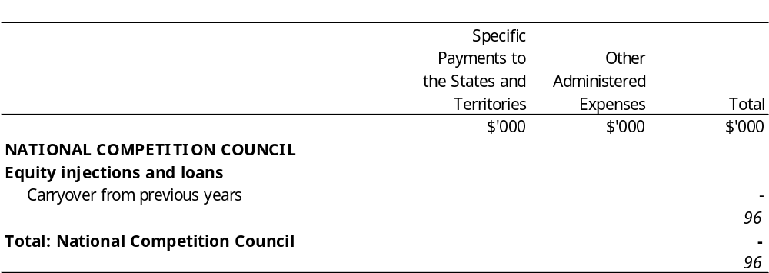
Title
Appropriation (light figures) – 2000-2001
Estimate (italic figures) – 1999-2000
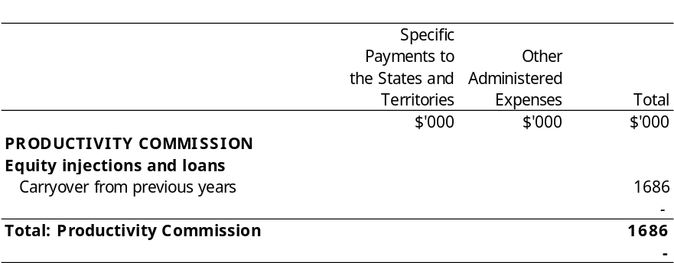

[Minister’s second reading speech made in—
House of Representatives on 9 May 2000
Senate on 22 June 2000]

(70/00)

